**Band Theory of Solids**

A useful way to visualize the difference between [conductors](http://hyperphysics.phy-astr.gsu.edu/hbase/electric/conins.html#c1), [insulators](http://hyperphysics.phy-astr.gsu.edu/hbase/electric/conins.html#c2) and[semiconductors](http://hyperphysics.phy-astr.gsu.edu/hbase/solids/intrin.html#c1) is to plot the available energies for electrons in the materials. Instead of having [discrete energies](http://hyperphysics.phy-astr.gsu.edu/hbase/bohr.html#c1) as in the case of free atoms, the available energy states form [bands](http://hyperphysics.phy-astr.gsu.edu/hbase/solids/band.html#c2). Crucial to the conduction process is whether or not there are electrons in the conduction band. In insulators the electrons in the valence band are separated by a large gap from the conduction band, in conductors like metals the valence band overlaps the conduction band, and in semiconductors there is a small enough gap between the valence and conduction bands that thermal or other excitations can bridge the gap. With such a small gap, the presence of a small percentage of a [doping](http://hyperphysics.phy-astr.gsu.edu/hbase/solids/dope.html#c1) material can increase conductivity dramatically.

An important parameter in the band theory is the [Fermi level](http://hyperphysics.phy-astr.gsu.edu/hbase/solids/fermi.html#c1), the top of the available electron energy levels at low temperatures. The position of the Fermi level with the relation to the conduction band is a crucial factor in determining electrical properties.

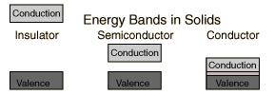

**Energy Bands for Solids**

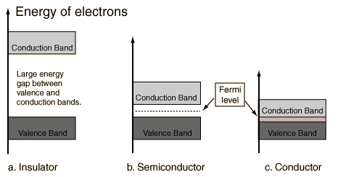

**Energy Bands Comments**

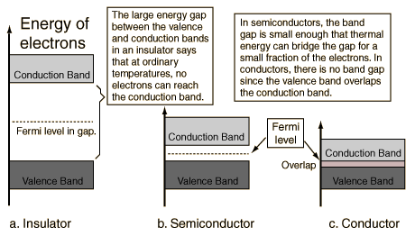

|  |
| --- |
| [Band gap dependence on interatomic spacing](http://hyperphysics.phy-astr.gsu.edu/hbase/solids/band2.html#c1) |

**Insulator Energy Bands**

|  |  |  |  |  |  |
| --- | --- | --- | --- | --- | --- |
| C:\Users\dell\Desktop\veena\mat sci\Band Theory for Solids_files\band4.gif | Most solid substances are [insulators](http://hyperphysics.phy-astr.gsu.edu/hbase/electric/conins.html#c2), and in terms of the[band theory of solids](http://hyperphysics.phy-astr.gsu.edu/hbase/solids/band.html#c1) this implies that there is a large forbidden gap between the energies of the [valence electrons](http://hyperphysics.phy-astr.gsu.edu/hbase/solids/sili.html#c5) and the energy at which the electrons can move freely through the material (the conduction band).  Glass is an insulating material which may be [transparent](http://hyperphysics.phy-astr.gsu.edu/hbase/mod4.html" \l "c2)to visible light for reasons closely correlated with its nature as an electrical insulator. The visible light photons do not have enough [quantum energy](http://hyperphysics.phy-astr.gsu.edu/hbase/mod2.html#c3) to bridge the band gap and get the electrons up to an available energy level in the conduction band. The visible properties of glass can also give some insight into the effects of "doping" on the properties of solids. A very small percentage of impurity atoms in the glass can give it color by providing specific available energy levels which [absorb](http://hyperphysics.phy-astr.gsu.edu/hbase/mod5.html#c2) certain colors of visible light. The ruby mineral (corundum) is aluminum oxide with a small amount (about 0.05%) of chromium which gives it its characteristic pink or red color by absorbing green and blue light.  While the doping of insulators can dramatically change their optical properties, it is not enough to overcome the large band gap to make them good conductors of electricity. However, the [doping of semiconductors](http://hyperphysics.phy-astr.gsu.edu/hbase/solids/dope.html#c1) has a much more dramatic effect on their electrical conductivity and is the basis for [solid state electronics](http://hyperphysics.phy-astr.gsu.edu/hbase/solids/sselcn.html).  **Semiconductor Energy Bands**   |  |  |  |  | | --- | --- | --- | --- | | For [intrinsic semiconductors](http://hyperphysics.phy-astr.gsu.edu/hbase/solids/intrin.html#c1) like [silicon](http://hyperphysics.phy-astr.gsu.edu/hbase/solids/sili.html#c2) and[germanium](http://hyperphysics.phy-astr.gsu.edu/hbase/solids/sili.html#c3), the [Fermi level](http://hyperphysics.phy-astr.gsu.edu/hbase/solids/fermi.html#c1) is essentially halfway between the valence and conduction bands. Although no conduction occurs at 0 K, at [higher temperatures](http://hyperphysics.phy-astr.gsu.edu/hbase/solids/fermi.html#c2) a finite number of electrons can reach the conduction band and provide some [current](http://hyperphysics.phy-astr.gsu.edu/hbase/solids/intrin.html#c3). In [doped semiconductors](http://hyperphysics.phy-astr.gsu.edu/hbase/solids/dsem.html#c1), extra energy levels are added.  The increase in conductivity with temperature can be modeled in terms of the [Fermi function](http://hyperphysics.phy-astr.gsu.edu/hbase/solids/fermi.html#c2), which allows one to calculate the [population of the conduction band](http://hyperphysics.phy-astr.gsu.edu/hbase/solids/fermi.html#c4).  **Conductor Energy Bands**   |  |  | | --- | --- | | In terms of the [band theory of solids](http://hyperphysics.phy-astr.gsu.edu/hbase/solids/band.html#c1), metals are unique as good [conductors](http://hyperphysics.phy-astr.gsu.edu/hbase/electric/conins.html#c1) of electricity. This can be seen to be a result of their [valence electrons](http://hyperphysics.phy-astr.gsu.edu/hbase/solids/sili.html#c5) being essentially free. In the band theory, this is depicted as an overlap of the valence band and the conduction band so that at least a fraction of the valence electrons can move through the material. | C:\Users\dell\Desktop\veena\mat sci\Band Theory for Solids_files\band6.gif | | C:\Users\dell\Desktop\veena\mat sci\Band Theory for Solids_files\band5.gif | |

**Silicon Energy Bands**

At finite temperatures, the number of electrons which reach the conduction band and contribute to [current](http://hyperphysics.phy-astr.gsu.edu/hbase/solids/intrin.html#c2) can be modeled by the [Fermi function](http://hyperphysics.phy-astr.gsu.edu/hbase/solids/fermi.html#c2). That current is small compared to that in [doped semiconductors](http://hyperphysics.phy-astr.gsu.edu/hbase/solids/dope.html#c5) under the same conditions.

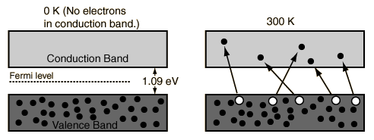

**Germanium Energy Bands**

At finite temperatures, the number of electrons which reach the conduction band and contribute to [current](http://hyperphysics.phy-astr.gsu.edu/hbase/solids/intrin.html#c2) can be modeled by the [Fermi function](http://hyperphysics.phy-astr.gsu.edu/hbase/solids/fermi.html#c2). That current is small compared to that in [doped semiconductors](http://hyperphysics.phy-astr.gsu.edu/hbase/solids/dope.html#c5) under the same conditions.

